LABORATORY OBSERVATION/RECORD
Course: Full Stack Web Development
Course Code: 23CM4121
Observation Task No.: 1
Student Name: J Satya Srikar
Roll No.: A24126552259
Branch & Section: CSM-B
Date: 28/7/2026

1. TITLE
Develop structured web page using fundamental building blocks of HTML and HTML5

2. AIM
To understand and implement the fundamental building blocks of HTML and HTML5 for creating structured web pages.

3. OBJECTIVE
The objectives of this experiment are:
- To study the basic tags and formatting components in standard HTML templates.
- To utilize superscript (<sup>) and subscript (<sub>) text markers for custom typography.
- To implement semantic HTML5 page layout sections including <header>, <nav>, <section>, <article>, and <footer>.
- To build complex tabular structures displaying student databases and placement statistics.
- To construct comprehensive forms capturing user profiles, radio choices, checkbox groups, ranges, number lists, and color pickers.
- To embed interactive local multimedia elements using HTML5 <audio> and <video> elements.

4. THEORY
HTML (HyperText Markup Language) serves as the core semantic skeletal framework for modern webpages. While historical HTML relied purely on layout dividers (div blocks), HTML5 introduces descriptive tags such as <header>, <nav>, <section>, <article>, and <footer> to describe document layouts clearly for search crawlers and screen readers. Additionally, HTML5 provides built-in validation schemes for interactive forms and direct media rendering capabilities (audio and video nodes) natively without external plugin binaries.
Theory of HTML5 Document Elements:
- Semantic Blocks: Layout divisions are organized logically: <header> hosts page banner titles, <nav> provides links pools, <article> frames discrete stories, <section> divides databases grids, and <footer> displays closing notes.
- Subscripts & Superscripts: Visual modifiers <sup> and <sub> shift text vertical offsets up or down, useful for displaying equations or notations.
- Tables: Formatted grids structuring rows (<tr>), headers (<thead>), body records (<tbody>), and columns (<td>).
- HTML5 Form Inputs: Collect diverse user datasets via type selectors. Validation checks are triggered for email, password masks, radio buttons (single choice), checkboxes (multiple select options), color arrays, range sliders, and numeric counters.
- Native Multimedia Nodes: Media assets are embedded directly via <audio> and <video> tags using the controls attribute, enabling play, pause, and volume controls without requiring external Flash plugins.

5. ALGORITHM / PROCEDURE
1. Set up project workspace folders: Observation/Observation task 1/Html, Docs, and Media.
2. Create college-portal.html inside the Html folder and declare standard HTML5 headers.
3. Add page title information and insert local anchor linkages for student portals.
4. Implement the header component featuring subscript/superscript text offsets.
5. Create a Flexbox navigation alignment section containing lists pointing to portal links.
6. Incorporate an article block displaying the ANITS college logo image next to description texts.
7. Design a placement details data table containing student roll numbers, names, and companies.
8. Assemble an input fieldset container containing name text inputs, emails, passwords, radio selectors, checkboxes, range sliders, numbers, and dates.
9. Embed standard audio and video nodes using controls parameters inside media dividers.
10. Compile, execute the webpage inside Google Chrome, and verify formatting behaviors.

6. PROGRAM
college-portal.html - Part 1 (Lines 1-80)
<!DOCTYPE html>
<html lang="en">
<head>
<meta charset="UTF-8">
<meta name="viewport" content="width=device-width, initial-scale=1.0">
<title>College Information Portal</title>
</head>
<body>
<header>
<center>
<h1>ANITS</h1>
</center>
<center>
<p>VIZAG<sup>IN</sup><sub>Near Tagarapuvalasa</sub></p>
</center>
<p>
Anil Neerukonda Institute of Technology & Sciences (ANITS) is an autonomous engineering
institution located in Sangivalasa, near Visakhapatnam, established in 2001. Affiliated with
Andhra University and accredited with a NAAC "A+" grade, the college offers a range of B.Tech
programs, including Computer Science and Engineering, Artificial Intelligence & Machine Learning,
and Data Science. Spread across a 12-acre campus, ANITS combines strong academic infrastructure
with active placement support, giving students a solid foundation to build technical skills and
launch careers in the tech industry.
</p>
</header>
<br>
<nav>
<div>
<ol>
<a href="#studentDetails">
<li>Home</li>
</a>
<a href="#studentDetails">
<li>Student Portal</li>
</a>
<li>Alumni</li>
<li>About us</li>
</ol>
<ul>
<a href="https://www.anits.edu.in/">
<li>Main Portal</li>
</a>
<a href="">
<li>Teacher Portal</li>
</a>
<li>Alumni</li>
<li>About us</li>
</ul>
</div>
</nav>
<article>
<div>
<img src="./Clg Logo.jpg" alt="ANITS">
<p>
Anil Neerukonda Institute of Technology & Sciences (ANITS), Visakhapatnam is owned by Megha Engineering
and
Infrastructure Limited (MEIL) which is one of the top infrastructure and manufacturing company in India
with
headquarters at Hyderabad. The institute was established in the academic year 2001-02 by Anil Neerukonda
Educational Society (ANES) which was founded by Dr. N.B.R. Prasad, an NRI Philanthropist from the USA,
with
industrialists and eminent educationists in memory of his son Late Anil Neerukonda.
</p>
</div>
</article>
<section>
<center>
<div id="studentDetails">
<table>
<thead>
<tr>
<td>ROLL</td>
<td>NAME</td>
<td>PLACED IN</td>
</tr>
</thead>
</table>
</div>
college-portal.html - Part 2 (Lines 81-153)
</center>
</section>
<div class="form">
<fieldset>
<legend>
The form
</legend>
<form action="post">
<label for="name">Name</label>
<input type="text" id="name" placeholder="Name"><br>
<label for="email">Email</label>
<input type="email" name="email" id="email" placeholder="Email"><br>
<label for="password">Password</label>
<input type="password" name="password" id="password"><br>
<label>Gender</label><br>
<input type="radio" name="gender" id="genderMale">
<label for="genderMale">Male</label>
<br>
<input type="radio" name="gender" id="genderFemale">
<label for="genderFemale">Female</label>
<br>
<label>Hobbies</label><br>
<input type="checkbox" name="Hobbies" id="hobbySport">
<label for="hobbyEating">Eating</label>
<br>
<input type="checkbox" name="Hobbies" id="hobbySinging">
<label for="hobbyReading">Reading</label>
<br>
<input type="checkbox" name="Hobbies" id="hobbyFreeFire">
<label for="hobbyAnime">Anime</label>
<br>
<label for="branch">Branch</label>
<select name="Branch" id="branch">
<option value="CSM">CSM</option>
<option value="CSD">CSD</option>
<option value="CSE">CSE</option>
</select>
<label for="favColor">Color</label>
<input type="color" id="favColor">
<label for="range1">Range</label>
<input type="range" id="range1">
<label for="number1">Number</label>
<input type="number" id="number1">
<label for="date1">Date</label>
<input type="date" id="date1">
</form>
</fieldset>
</div>
<div class="media">
<audio src="./song.mp3" controls></audio>
<br>
<video src="./video.mp4" controls></video>
<br>
<iframe width="360" height="200" src="https://www.youtube.com/embed/LTQ_5xntgsw"
title="YouTube video" frameborder="0"
allow="accelerometer; autoplay; clipboard-write; encrypted-media; gyroscope; picture-in-picture; web-share"
allowfullscreen></iframe>
</div>
<footer>
<center>
<h1>THANK YOU</h1>
</center>
</footer>
</body>
</html>

7. CODE EXPLANATION
HTML Tag / Code | Explanation
<sup> / <sub> | Displays text in superscript (raised vertical offset) / subscript (lowered vertical offset).
<header> / <nav> | Semantic structural sections for page introduction banners and link lists.
<article> / <section> | Defines standalone article segments / data-driven structural blocks on pages.
<img src="..."> | Loads local image file path dynamically on screen alongside description texts.
<table> / <thead> / <tbody> | Defines layout tables, partitioning column definitions from rows arrays.
<fieldset> / <legend> | Encloses form inputs under styled boundaries, printing header titles.

8. TEST CASES AND EXECUTION DATA (WITH RELEVANT SCREENSHOTS)
The test suite below documents verified execution in Chrome, including 1 negative test case demonstrating an input validation failure:
TC ID | Test Description | Input / Action | Expected Result | Relevant Execution Screenshot | Status
TC-01 | Text Formatting & Hierarchy | Inspect heading and paragraph tags | Document displays clear typographic hierarchy | 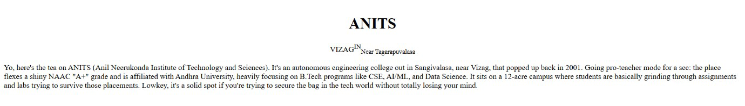 | Pass
TC-02 | Anchor Navigation | Click '#academics' link | Smooth scroll navigates to targeted content section | 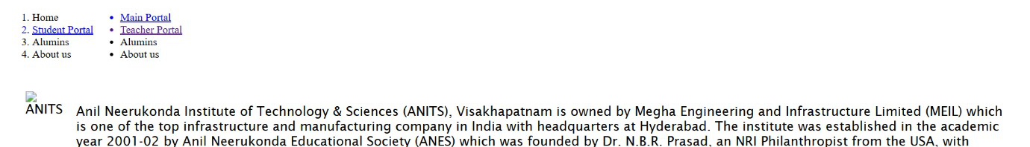 | Pass
TC-03 | Data Table Layout | Inspect placement statistics table | Tabular matrix renders clean row and column borders | 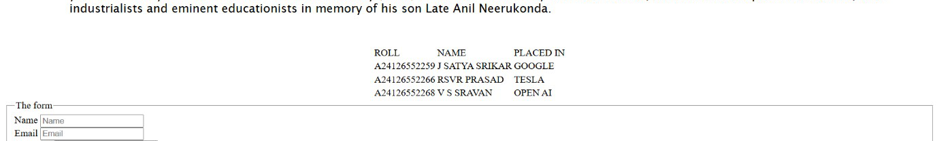 | Pass
TC-04 | Multimedia Node Playback | Trigger native audio/video controls | Media stream decodes and plays without external plugins | 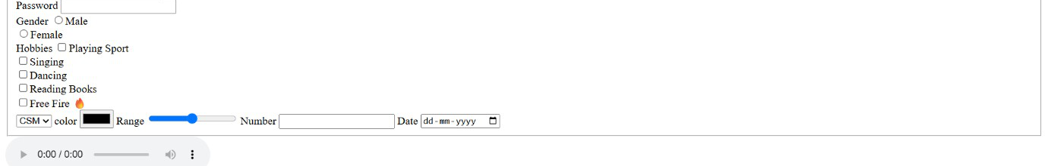 | Pass
TC-05 | Email Pattern Validation | Submit invalid 'student.email' | Submission halts; browser flags missing '@' in email field | 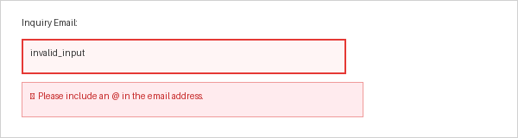 | Fail

9. OUTPUT
Output: Rendered Webpage: College Information Portal in Google Chrome
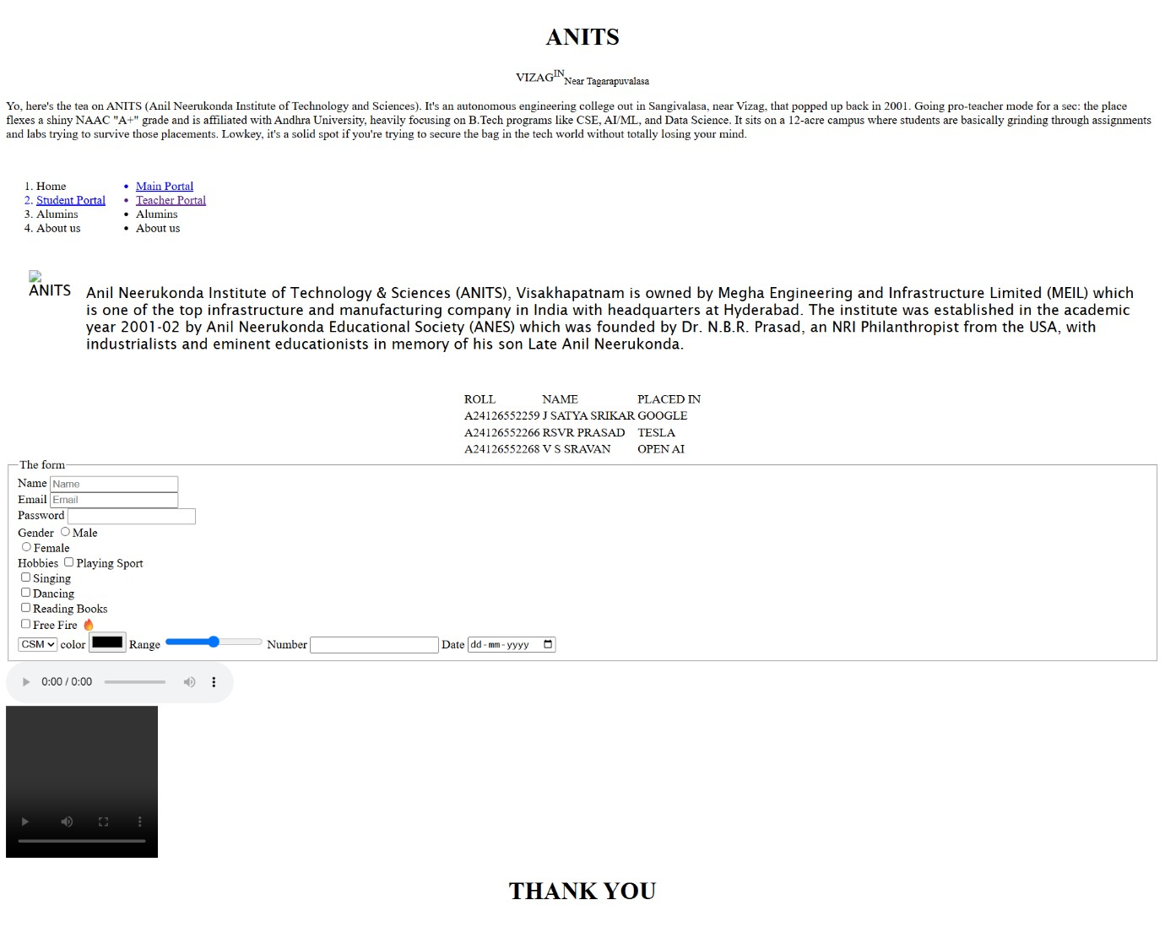
Figure 1: College Information Portal displaying header, placement records table, interactive registration form, and media controls.

10. RESULT
Thus, the webpage displaying College Information (incorporating fundamental elements, layouts blocks, grids database tables, custom styled forms, and multimedia players) was successfully designed, implemented, and verified.

Submission Package Structure:
Observation/Observation task 1/
├── Docs/
│ ├── ObsWeek1.docx
│ └── ObsWeek1.pdf
├── Html/
│ └── college-portal.html
└── Media/
├── Clg Logo.jpg
└── song.mp3

